Q SCI 291
Application Problem Answers from our Text for Weeks 9 and 10

Problem 76, page 321
A) N’(t) = 900/(t + 9)² and t > 0, so N’ > 0 and N is increasing on (0,∞). Never decreases.
B) N”(t) = -[900(2t + 18)/(t + 9)⁴] = -1800/(t + 9)³ so N”(t) < 0 for t > 0 and the graph of N is concave downward on (0,∞).
C) No vertical asymptotes. Use L’Hopital’s Rule to find lim t → ∞ N(t) = 100 so 100 is a horizontal asymptote.
D) y intercept: N(0) = 0 and x intercept: N(t) = 0 , t = 0 so (0, 0) is both an x and y intercept.

Problem 84, page 322
Use the four step graphing strategy and graph.
Step 1: domain w > 5 or [5, ∞); no intercepts; vertical asymptote is w = 0; horizontal asymptote = 0.06
Step 2: S’(w) = -26/w² which is < 0 for w > 5. Thus, S is decreasing on [5, ∞).
Step 3: S”(w) = 52/w³ which is > 0 for w > 5. Thus, S is concave upward on [5, ∞).
Step 4; Graph of S.
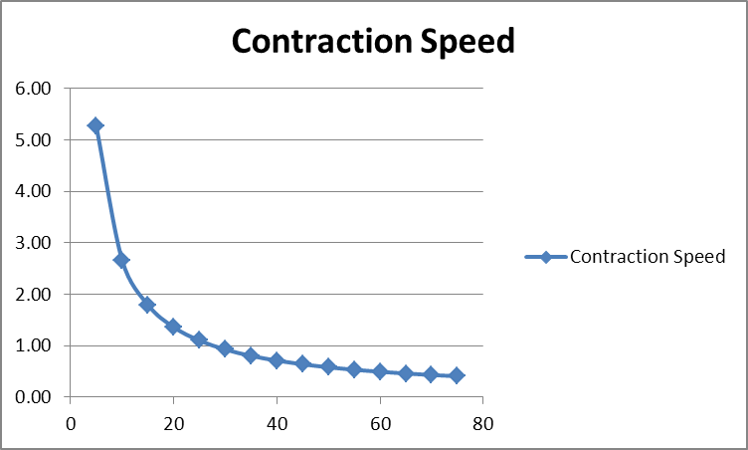

Problem 12, page 341
A) R(x) = xp = 400x – 0.4x² and R’(x) = 400 – 0.8x. To find max R, set R’ = 0 and solve for x. So, 400 – 0.8x = 0 and x= 500. R”(x) = - 0.8 which is < 0 for all x. Thus, a production of 500 cameras a week will max weekly revenue. The max weekly revenue is = 400(500) – 0.4(500)² = $100,000/week and the price /camera = 400 – 0.4(500) = $200
B) P(x) = R(x) – C(x) = 240x – 0.4x² – 2000 and P’(x) = 240 – 0.8x. To find max P, set P’ = 0 and solve for x. So, 0.8x = 240 and x = 300. P”(x) = - 0.8 which is < 0 for all x. Thus, a production of 300 cameras a week will max weekly profit. The max weekly profit is = 240(300) – 0.4(300)² – 2000 = $34000/week and the price/camera = 400 – 0.4(300) = $280

Problem 22, page 342
R(t) = xp and x = 60 + 6t and p = 0.3 – 0.02t, thus R = (60 + 6t)(0.3 – 0.02t) = 18 + 0.6t – 0.12t²
R’(t) = 0.6 – 0.24t so t = 2.5 weeks. R’ > 0 on [0, 4] and R”(t) = - 0.24 < 0 on [0, 4]
Thus, max R = 18 + 0.6(2.5) – 0.12(2.5)² = $18.75

Problem 28, page 342
Let x = number of bottles order and y = number of times orders placed per year. Then total cost is: C(x) = 40y + 5x We also know that: xy = 200, so y = 200/x so we can write C(x) = 40(200/x) + 5x = 8000/x + 5x
C’(x) = - 8000/x² + 5 which we set = 0 and find x² = 1600 and x = 40 (the only critical value as x > 0). Also, we see that y = 200/40 = 5
C”(x) = 8000/x³ > 0 for all x so the critical point is a min. C(40) = 40y + 5x = 40(5) + 5(40) = $400

Problem 36, page 343
C’(x) = -16k/x3 + 2k/(10 – x)³ = [-16k(10 – x)³+ 2kx³]/ (x³(10 – x)³ Now we set C’ = 0 to find the critical point.
We have: 2kx³ = 16k(10 – x)³ so x³ = 8(10 – x)³ and x = 2(10 – x) and x = 20/3
C”(x) = 48k/x⁴ + 6k/(10 – x)⁴ and is > 0 for all x. Thus, we have a local min at x = 20/3
Need to check the end points for x to see if we have a global min.
C(0.5) = 32.01k; C(20/3) = 0.27k; C(9.5) = 4.09k
Thus, x = 20/3 is a global or absolute min.

Problem 50, page 457
S(3,2) = $360,000 and S(2,3) = $540,000

Problem 58, page 458
R(8,1) = 8k and R(4, 0.2) = 2500k

Problem 86, page 466
R(x, y) = xp + qy = (230x – 9x² + xy) + (130y + xy -4y²)
R_{x}(x, y) = 230 – 18x + y + y = 230 - 18x + 2y
R_{x}(10, 5) = 230 – 18(10) + 2(5) = 60
At a production level of ten 10-speed and five 3-speed bicycles per week, increasing production of 10-speed bicycles by one unit while holding production of 3-speed bicycles constant at five units, revenue will increase approximately $60.
P(x, y) = R(x, y) – C(x, y) = 230x – 9x² + xy + 130y + xy – 4y² – 200 – 80x – 30y = 150x – 9x² + 2xy + 100y – 4y² – 200
P_{x}(x y) = 150 – 18x + 2y and P_{x}(10, 5) = -20
At a production level of ten 10-speed and five 3-speed bicycles per week, increasing production of 10-speed bicycles by one unit while holding production of 3-speed bicycles constant at five units, profit will decrease approximately $20.

Problem 92, page 466
f_{q}(p, q) = -2q < 0 and g_{p}(p, q) = -8 < 0 Thus, the two products are complementary.
Problem 94, page 467
R_{L}(L, r) = k/r⁴ and R_{r}(L, r) = -4kL/r⁵
R_{L}(4, 0.2) = 625k which is the approximate change in resistance per unit increase in length when the radius is held constant when L = 4 and r = 0.2
R_{r}(4, 0.2) = -50000k which is the approximate change in resistance per unit increase in radius when the length is held constant when L = 4 and r = 0.2

Problem 32, page 474
A) For p = 40 and q = 50, x = 20 and y = 45. For p = 45 and q = 55, x = 5 and y = 40
B) P(x, y) = R(x, y) – C(x, y) = xp + yq – 25x – 30y = x(p – 25) + y(q – 30); rewriting in terms of p and q we have: P(p, q) = (p – 25)(130 – 4p + q) + (q – 30)(115 + 2p – 3q) = 170p – 4p² + 3pq + 180q – 3q² – 6700
Now, find: P_{p}(p, q) = 170 – 8p + 3q and P_{q}(p, q) = 180 + 3p – 6q
Setting both equations = 0 we find: p = 40 and q = 50 which is a critical point of P(p, q).
Now, we take 2nd derivatives to check for local extrema. Using the procedure shown on page 469: A = P_{pp} = -8; B = P_{pq} = 3; and C = P_{qq} = -6. Thus, AC = 48 and B² = 9, so AC – B² = 39 > 0. With A < 0 we see that for p = 40 and q = 50, we have a local maximum profit = $1200. This profit is realized by producing x = 20 brand A sleeves and y = 45 brand B sleeves.

Problem 34, page 475
The square of the distance from P to B is: (x – 6)² + (y – 9)²; square of the distance from P to C is: (x – 9)² + y²; and the square of the distance from P to A is: x² + y². Expanding these expressions and adding like terms we have the following expression for the total square of the distance to minimize: 3x² + 3y² – 30x – 18y + 198 D(x, y), where D = sum of squared distance.
Next, we find D_{x}(x, y) = 6x – 30 and set = 0 and find x = 5. And, D_{y}(x, y) = 6y – 18 = 0, so y = 3. This is a critical point. Now, we take 2nd derivatives to check for local extrema. Using the procedure shown on page 469: A = D_{xx} = 6; B = D_{xy} = 0; and C = D_{yy} = 6. Thus, AC = 36 and B² = 0, so AC – B² = 36 > 0. With A > 0 we see that we have a local minimum squared distance where P is located at x = 5 and y = 3.

Problem 38, page 475
Volume of the box is V = xyz. We have 144 in. of tape to stretch around the box in three bands. So, 4(x + y + z) = 144 or x + y + z = 36. Hence, z = 36 – x – y and V = xy(36 – x – y). Now, V_{x}(x, y) = 36y – 2xy – y² or y(36 – 2x – y) = 0. And, V_{y}(x, y) = 36x – x² – 2xy or x(36 – x – 2y) = 0. Because both x and y >o we solve two equations for x and y: 36 – x – 2y and 36 – 2x – y so x = 12 and y = 12. Hence this is a critical point. Also, z = 36 – x – y = 12. Now, we take 2nd derivatives to check for local extrema. Using the procedure shown on page 469: A = V_{xx} = -2y; B = V_{xy} = 36 – 2x – 2y; and C = V_{yy} = -2x. At the critical point we have: A = -2(12) = -24 < 0; B = 36 -2(12) – 2(12) = -12 < 0; C = -2(12) = -24 < 0. Thus, AC = 576 and B² = 144, so AC – B² = 432 > 0. With A < 0 we see that we have a local maximum where x, y and z all = 12. Maximum box volume = 12*12*12 = 1728 cu.in.

